Cultural Tour of Otavalo (full-day): includes guide, professional driver, and lunch at a local restaurant (private)
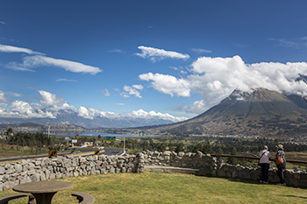 | 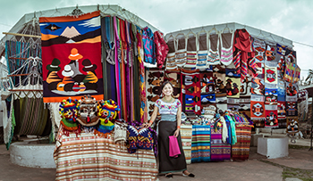
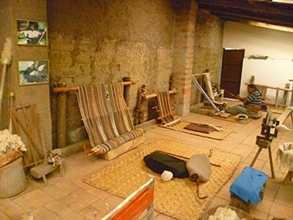 | 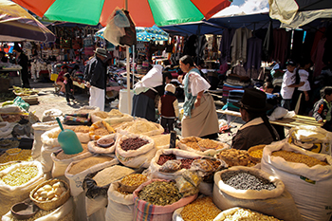
Ecuador’s Northern Province of Imbabura offers some of the most majestic and peaceful scenery in the country. It is known for its many lakes, lagoons, mountains, and volcanos, as well as its marvelous cultural experiences. This full-day tour of Otavalo and the surrounding valleys offers the opportunity to experience both nature and folklore in a single journey.
On this day, we visit Mira Lago, a warm and inviting touristic area offering spectacular views of the San Pablo Lake and Imbabura volcano. Visitors get a chance to connect with nature in this stunning location.
Heading a little further north, we reach the small Andean town of Otavalo, known for its myriad markets that fill it with life and activity. The history of the Otavalo Market harkens back to the 16th century when indigenous merchants played a crucial role as traders and traveling salesmen. Nowadays, its exceptional offerings of textiles, jewelry, musical instruments, crafts, and more, make it a must-see for shopping but also for an authentic cultural market experience that has remained alive for centuries.
Along our journey, we stop in at textile workshop, where we take a closer look at the process of producing intricate traditional textiles. We will have a close look at the knitting process and how the colorful patterns are made.
Ecuador’s rich culinary culture invites you to get up-close and personal with hundreds of ingredients and products available at the Vegetable Market. These ingredients are the basis for many traditional dishes. Here, we admire some of Ecuador’s tropical fruits, like passion fruit and capulí (Andean cherry), which makes for a very lively and satisfying Andean experience.
Our day winds down in Tayta Gundo Kaya Wasi, which means Andean Music House in Kichwa. This traditional-style building houses a space dedicated to strengthening indigenous culture through popular Kichwa music. The cultural education project here promotes activities for children and young people from rural communities. We visit its quaint museum of wind and string instruments, as well as the workshop where these instruments are built using bamboo and other natural materials.
We have lunch at a local restaurant, where get to try delicious traditional food from the Province.

Notes
• Daily tour departs from Quito and lasts approximately 9 hours.
• This tour includes walking at an altitude of 8,434 ft (2,560 m).
Recommendations
• Dress in layers and bring a sweater or jacket.
• Wear comfortable walking shoes.
• Bring a hat, sunglasses, and sun protection (SPF 40+).
• Depending on the weather, bring a raincoat or umbrella.
Included
• Private guide and professional driver, lunch, all entrance fees.
Not Included
• Drinks, tips, personal expenses.

